# 

**DEPARTMENT OF COMPUTER ENGINEERING**

**KHWOPA COLLEGE OF ENGINEERING**

**LIBALI , BHAKTAPUR**



|  |
| --- |
| **BY:** |
| **SAKAR PAUDEL (C) (CRN-KCE075BCT037)**  **ANUSHIL TIMSINA (CRN-KCE075BCT012)**  **NITESH KUMAR DAS (CRN-KCE075BCT022)**  **SANDEEP SUBEDI (CRN-KCE075BCT039)** |
|  |



|  |  |
| --- | --- |
| PROJECT TITLE | final report on e-voting |

**DEPARTMENT OF COMPUTER ENGINEERING**

**KHWOPA COLLEGE OF ENGINEERING  
LIBALI, BHAKTAPUR**

**CERTIFICATE**

This is to certify that the project entitled "**E-VOTING**" submitted by Mr. Anushil Timsina , Nitesh Kumar Das , Sakar Paudel , Sandeep Subedi in a partial fulfillment of the requirements for the award of the Degree of Bachelor of Engineering in Computer Engineering of Tribhuvan University , is a bonafide work to the best of my/our knowledge and may be placed before the examination Board for their consideration.

**Panel of Examiners:**

|  |  |  |
| --- | --- | --- |
| **Name** | **Signature** | **Date** |
|  |  |  |
|  |  |  |
| **External Examiner** |  |  |
|  |  |  |
| Er…………………… |  |  |
|  |  |  |
| **Project Supervisor** |  |  |
|  |  |  |
| Er. ………………… |  |  |
|  |  |  |
| **Head of Department** |  |  |
|  |  |  |
| Er. Shiva K. Shrestha |  |  |

**ACKNOWLEDGEMENT**

First of all we would like to thank our HoD Er. Shiva Kumar Shrestha for his kind

support and guidance in generation of idea for our project.

We also express our deep gratitude to our classmates, faculty teachers who have

directly and indirectly helped us for doing our project.

We also thank and congratulate each other for self support and encouragements to do

this project .We are highly benefited by this training for our theory study too.

**ABSTRACT**

Our program is used for systematic voting which is safer ,secure and reliablethan the normal voting. The major problems we faced are run rime error ,crash , no storage location, increment problem. We solved the problems byusing non terminating function, declaring global variable etc. After this wecould make the programme satisfactory and get the result as per our objective. Still we are about to add many other features for problem solving solving approach.

**Table Of Contents**

# Chapter Title Page

# Title page 1

Certificate 2

Acknowledgements 3

Abstract 4

Table of contents 5-6

1 Introduction

* 1. Background 7
  2. Statement Of Problems
  3. Objectives
  4. Application
  5. Scope and limitation
  6. Report structure

1. Literature Review 8

3 Methodology 9

3.1 Algorithm 10

* 1. Flowchart 11
  2. Tools and platform 12

4 Result and discussion

4.1 Overview

4.2 Analysis of Results

1. Conclusion and Recommendation

5.1 Conclusion

5.2 Recommendation

**References**

**CHAPTER 1**

# INTRODUCTION

## 1.1 BACKGROUND

E-voting is a voting application that uses electronic means to take care of casting and counting votes.

## 1.2 STATEMENTS OF PROBLEMS

Hacking is the major problem, as regular voting is highly decentralized in most of the countries. That makes it hard to manipulate on large scale. If there is fraud on an online system (for example more votes than number of voters) all votes are invalid and should be re done again.

So to minimize this problem we have manipulated this system on small scale.

## 1.3 OBJECTIVES

To make a use of application like E-voting using C programming Language.

## 1.4 APPLICATION

This application is applicable to select the class representative, team leader, group leader.

## 1.5 SCOPE & LIMITATION

Scope of this application is to increase the speed of counting votes and saves time and fund.

As for the limitations of this application in large scale like elections of government it is nearly impossible to check if someone isn’t force to vote for someone. In most of the countries, you’re forced to vote alone in some kind of box where you have privacy. But there could be someone with a gun on your head when you vote on your computer at home. To minimize this we are going to make it in small scale where limited people can vote.

**1.6 REPORT STRUCTURE**

**CHAPTERS**

Literature review

Methodology

Result and discussion

Conclusion and recommendation

# CHAPTER 2

# LITERATURE REVIEW

E-voting is voting that uses electronic means of casting and counting votes. Depending on the particular implementation, e-voting may use standalone electronic voting machines or computers connected to the internet. It may encompass a range of internet services, from basic transmission of tabulated results to full-function online voting through common connectable household devices.

In this project E-voting, User (voters) have a certain identification number like their citizenship number which is unique for each user. The user is asked to enter their identification number. Once they enter their identification number then they have to type the option No: only one input value is accepted. And a voter can give only one vote at a time.

**CHAPTER 3**

**METHODOLOGY**

**3.1 ALGORITHM**

Step1: Start

Step2: Display welcome screen and rules

Step3: Display options of admin and vote mode

If option is for admin mode, ask password

Step4: If password is correct show the votes

If password is wrong goto step 2

Step 5: If vote mode is selected display candidate list

Step 6: Input the the vote from user

Step 7: If the vote is successful add vote to that candidate by one

Step 8: If error occurs diplay error message

Step 9: Display the close screen

Step 10 : Display main screen and repeat from step 2

Step 11: Stop

**3.2 Flowchart**

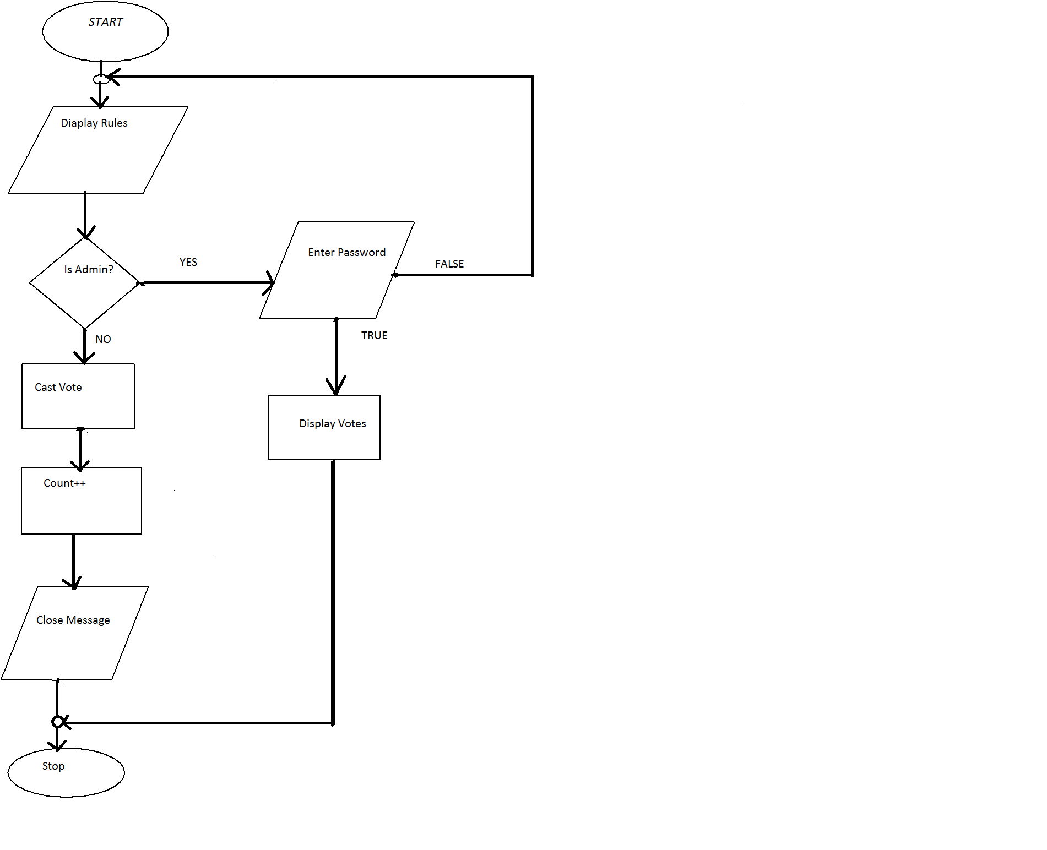

**Fig - Flowchart of E-voting**

**CHAPTER 4**

**RESULT AND DISCUSSIONS**

In this project,we have met our most of the expectations. The voting system has a general user interface system with a simple voting method using assosiated serial number of respective candidates.

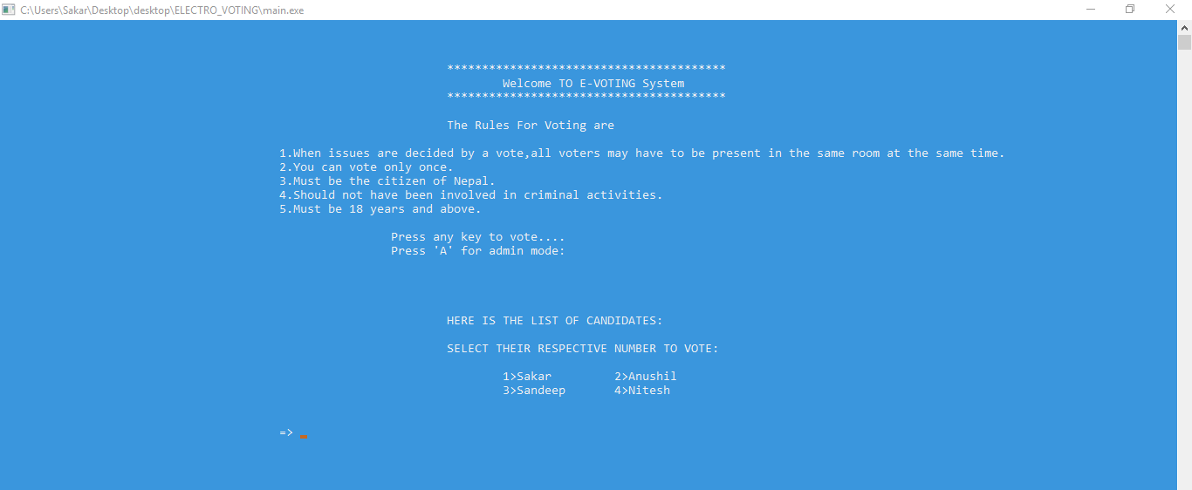

**Fig:**User Interface



**Fig:** Successful vote

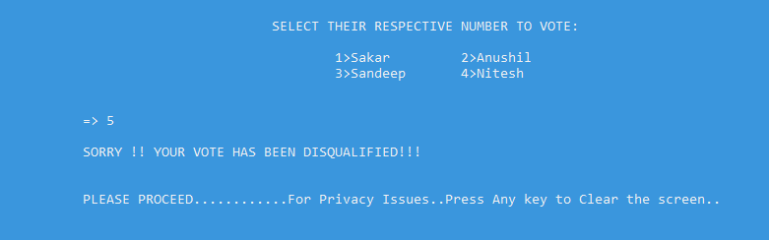

**Fig: Disqualified Vote**

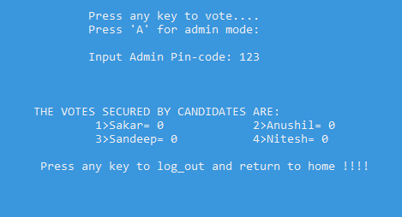

**Fig:** Vote Counting

**CHAPTER 5**

**CONCLUSION AND RECOMMENDATION**

**5.1 Conclusion**

The electronic voting system will incorporate all the features of manual voting system of Nepal was well as some of the improved features of it. In this user who is above 18 year’s register his/her informations on the system and one person can vote only once. The concept of file handling in C/C++ is used here to store the votes secured by the candidates. In this system, the percentage of vote loss is decreased due to general human mistakes. But if a person has pressed the wrong keys during voting he/she will not be able to vote again and hence his/her vote will be disqualified. The system decreases the cost and time of the election process. It is easy to use and time saving as well as not so difficult to debug.

**5.2 Recommendation**

We haven’t included list of voters and their unique ID number. This is actually useful for secure and more precise voting. This programme also faces run time error in certain cases. This can be improved by using file handling function ,time.h function, code encryption and using password for voting.

**REFRENCES**

**Website**

* programmingsimplified.com
* slideshare.net
* quora.com
* https://image.shutterstock.com

**Books**

Byron S. Gottfried, Jitendra Kumar Chhabra - Tata McGraw Hill Education Private Limited